**Patil Rushikesh Mukund. Address for Correspondence**

BE Electrical, sumit apt B-wing, kotwalnagar,

**Contact:** +91-8087467746  **Email:** rushi3455@gmail.com Tal-karjat Dist-Raigad. 410201.

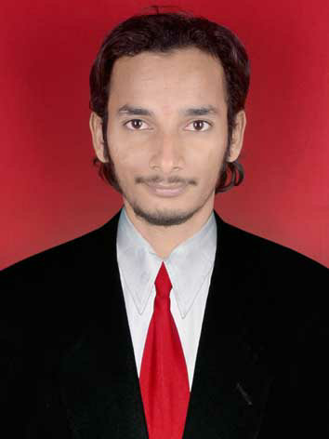



|  |  |
| --- | --- |
|  | |
| **Objective :** | |
| To work in a creative and challenging environment, where I can use my current skill sets, learn new things and implement them. I want to contribute my best in terms of output, knowledge and effort to explore myself fully and realize my potential to seek a platform where ideas can be turned into realities.  **Strengths :**   * Professional and positive attitude towards the work. * Ability to work in Co-ordination, Team worker. * Eger to learn new technologies, quick learner & adaptable to changing requirements. * Excellent communication skills, people management. * Can cope with failure and learn from mistakes.   **Academic :**  Completed BE (Electrical) with 62.23% (aggregated 57.96 %) from Nagpur University in 2013.  Completed Diploma (electrical power system) with 65.03 % from MSBTE in 2010.  Passed S.S.C. with 54.53 % from Pune Board.  **Industrial Exposure** **: CIPLA through Sanjay pawer engineering services.**  Company SPES (Cipla).  Designation Shift engineer  Duration April 2015 to Sept 2015  Department Electrical maintenance.  **Responsibilities:**   * Maintaining documentation for existing and new equipment of control and power system installations, Work permit . * Carry the preventive maintenance of machines and HT/LT control panels * Diagnoses cause of electrical / mechanical malfunction or failure of equipment or systems and repairs / replaces defective components.   **Industrial Exposure** **: ITTC Park LODHA (THANE)**  Company EFS Facility management.  Site ITTC Park LODHA  Designation Shift engineer  Duration Sept. 2015 to Feb 2016  Department Electrical maintenance.  **Responsibilities:**   * Put the proper maintenance of all machines in the companies. * Carry the preventive maintenance of machines and **HT/LT control panels** * Diagnoses cause of electrical / mechanical malfunction or failure of equipment or systems and repairs / replaces defective components. * Work in troubleshooting and repair problems in VFDs, **Chillers** and related components when required. Maintaining **HVAC system** in properly working condition. * Test electrical systems and continuity of circuits in electrical wiring, equipment, and fixtures, using testing devices. Maintaining **WTP** and **STP** plant. * Operation, Maintenance & troubleshooting of Electrical substations which includes **22 KV HT ACB** switchgears, **22000/433V Transformers**. * Operation, Maintenance & troubleshooting of **DG** Sets which includes Cummins Engine, Its fuel & water lines and Controls * Maintaining documentation for existing and new equipment of control and power system installations, Work permit Daily **MIS/DSR** report.   **Industrial Exposure** **: GENERAL MILLS (POWAI)**  Company CBRE South Asia pvt. Ltd.  Site GENERAL MILLS (POWAI)  Designation Facility Executive  Duration June. 2016 to Still  Department Maintenance.  **Responsibilities:**   * Put the proper maintenance of all machines in the companie. * Put the proper records of AMC. * Coordinate with different vendors and get the job done before deadline. * Take the quotation from different supplier, made comparative and suggest the L1 to management. And H1 in case of scraping material. * Have done annual report, MMR, QBR, Annual shut down, DG B-check. * Maintenance of PAC, VESDA, WLD, VRV, DUCTABLE UNITS, CASSETTES UNIT, UPS, ISOLATION X'MAR, FAS, PAS, SPRINKLERS, SMOKE & HEAT DETECTORS, NOVEC .   **Projects :**  **Diploma :** “ Monorail ”  **Degree : “**Maximum demand controller.  **Technical Skills :**   * Complete the 3 months P.L.C Automation course from prolific institute. * Good operating knowledge of MS Office. * Basic knowledge of E-plan software. * Completed the one month training in the Tata power company limited (operation and maintenance, trombay ) * Successfully completed certified course in MS-CIT with 80%   **Personal Details :**  Hobbies : Playing cricket (outdoor games), Listening songs, Reading books, Traveling.  Date of Birth : 12th oct 1989  Gender : Male.  Marital status : single.  Nationality : Indian.  Permanent Address : sumit apt B-wing, kotwalnagar,  Tal-karjat, Dist-Raigad. 410201,  Maharashtra, India.  Contact no. : 8087467746 / 8888802083  Languages Known : English, Hindi and Marathi.  Current salary :  25000 Expected Salary :  35000 Notice Period : 30 Days | |
| **DECLRATION:**  I hereby declare that the above information’s provided are True to best of my Knowledge and belief.  **DATE:**  **PLACE:**  **Rushikesh Mukund Patil** | |
|  | |
|  | |